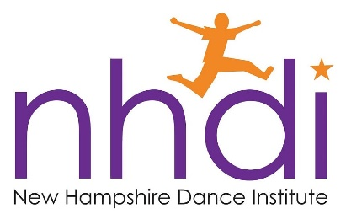
New Hampshire Dance Institute
PO Box 1116
Keene, NH 03431
(603) 355-8911
nhdi@nhdi.org

NHDI Year-Long Program

New Hampshire Dance Institute (NHDI) is an affiliate of National Dance Institute (NDI) founded by world-renowned New York City Ballet principal dancer, Jacques d’Amboise. It was his goal to bring the transformative power of the performing arts to school children. NHDI's dance style emphasizes athleticism, energy, rhythm, group dynamics, and performance. The NHDI Year-Long Program, which began in 1986, is currently partnered with 12 schools in the Monadnock Region for the 2019-20 school year.

Classes: Students meet on a weekly basis with their NHDI Teaching Artist during the school day. Students should wear sneakers for class, and be committed to participate to their fullest ability. Students with discipline/attendance issues risk their place in class.

2020 EVENT OF THE YEAR: The 2019-20 Year-Long Program will culminate Memorial Day weekend when 300 dancers from all 12 participating schools come together for a series of four performances at Keene State College’s Redfern Arts Center. Students are required to participate in all rehearsals the week prior to the shows as well as all four performances. Students who do not attend rehearsals or performances without prior acknowledgement and for reasons other than injury or illness may not perform in the show or may not be able to participate in the program the following year. Parents will be asked to volunteer for costume creation, lobby sales, ushering and chaperoning.

2020 NHDI EVENT OF THE YEAR -- IMPORTANT DATES
Pep Rally
Held in Spaulding Gymnasium at Keene State college, Friday March 13th 6:00-8:00 pm
Rehearsals at Redfern Arts Center
May 19-22 -- Rehearsals will take place all this week sometime between 3:00-8:00pm; the specific school schedule will be determined later in the year. Each school will rehearse at least three evenings as well as during the school day on Friday afternoon, May 22.
Performances at Redfern Arts Center
Fri, May 22 -- 7:00pm Sat, May 23 -- 1:30pm, 7:00pm Sun, May 24 -- 1:30pm

FEES AND REGISTRATION
$215 - 1st child $180 - 2nd child
A $50 deposit is due to NHDI along with online registration by October 18. The remaining balance is due by February 14, although you may pay in full now. Students must be registered directly with NHDI to participate. Please give a check (payable to NHDI) or cash to the school office or mail your check to the NHDI office at: PO Box 1116, Keene, NH 03431. To register go to: http://www.familyid.com/new-hampshire-dance-institute-nhdi

FINANCIAL ASSISTANCE
NHDI strives to give all children a chance to dance. Online applications for financial assistance must be accompanied by the $50 deposit and registration by October 18. Assistance is limited. Applications received without deposit or after assistance is distributed will not be considered.
To complete the Financial Assistance Application go to:
http://www.familyid.com/new-hampshire-dance-institute-nhdi
During the year, there will also be an optional fundraising opportunity with NHDI's annual calendar raffle ticket sales. Ticket sales are applied directly to students' fees. More details to come in December.

PARENT MEETING
There will be a parent meeting at _________________School soon. Details with the date/time of the meeting TBA.

For more information: http://www.nhdi.org/year-long-parents/

