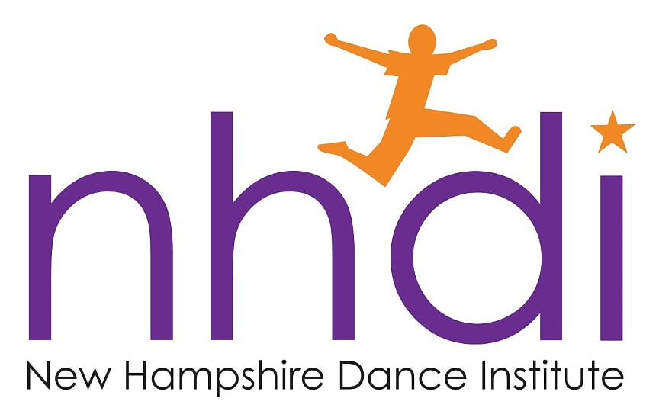

Dear Dancer,

We would like to know how you feel about your NHDI experience. Please take a few moments to answer the following questions:

What things did you most enjoy learning in your NHDI class?

How did performing on stage make you feel?

What things did NHDI help you learn about yourself?

If you could do one thing to improve NHDI what would that be?

_________________________________________________________________________________________________________

Name Date

_________________________________________________________________________________________________________

School Years Participated in the Program

THANK YOU!

