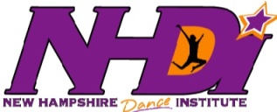

Dear Parents,

Please take a minute and answer the following questions. We love hearing from our families, and your feedback helps us to improve our program. You can either give completed forms to your school coordinator or mail them to NHDI, PO Box 1116, Keene NH 03431. Please feel free to use the back of the page if you need more space. Thank you for your help.

- How did your child benefit from his/her NHDI experience?

- In what ways do you see NHDI benefit your school community?

- How do you feel about your NHDI experience?

- What suggestions can you give for improving the program in general?

__________________________________________________________________________________________________________________
Name

__________________________________________________________________________________________________________________
School Years with NHDI

