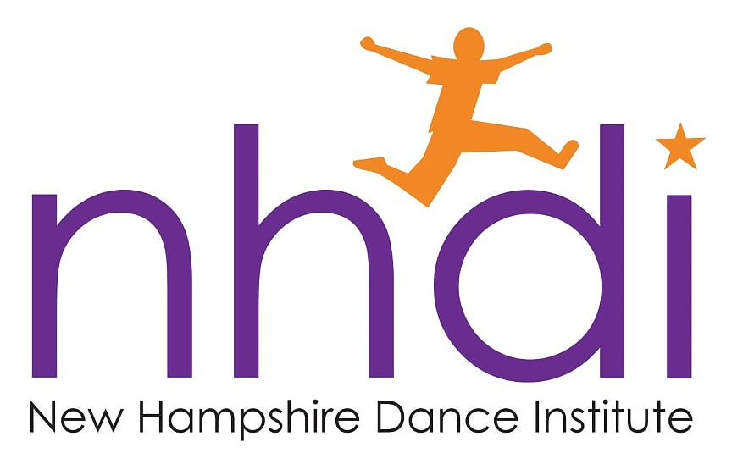

Annual Fundraising Raffle

The annual raffle is the sole fundraiser for dancers in NHDI’s Year-long Program. Like last year, we are doing a calendar raffle. Every day in February, we will draw for at least one nice prize. That’s at least 28 chances to win – we’ll have more than one drawing on some days if we collect more than 28 prizes.

Also, like last year, we are asking the schools to solicit donations for three prizes each to the raffle – gift cards/certificates in the $25+ range are preferred. The prizes (or at least a firm commitment to specific prizes) are due to NHDI no later than Oct. 31. We will distribute tickets and envelopes to you at the December coordinator meeting. Encourage your dancers (on behalf of their parents) to sell as many tickets as possible. Please return the envelopes with ticket stubs and money to NHDI at the January coordinator meeting or earlier, if you can.

The proceeds of the raffle are used to help families offset the cost of their dancer program fees. For every ticket a family sells, their fee is reduced by $5, so it is quite feasible for a family to fund their child’s remaining balance by selling raffle tickets. Be sure families submit the raffle ticket stubs and money in the envelope provided. Checks can be used to purchase tickets, and must be made payable to NHDI.

NOTE: Selling more tickets than needed to cover a dancer’s fee is also encouraged and welcome. We can use the additional proceeds to offset the printing and other administrative costs of the raffle – or in other discretionary ways, such as subsidizing another dancer in need.

All ticket stubs and money are due in the NHDI office absolutely NO LATER THAN Friday, Jan. 31. Drawings begin Feb. 1.

