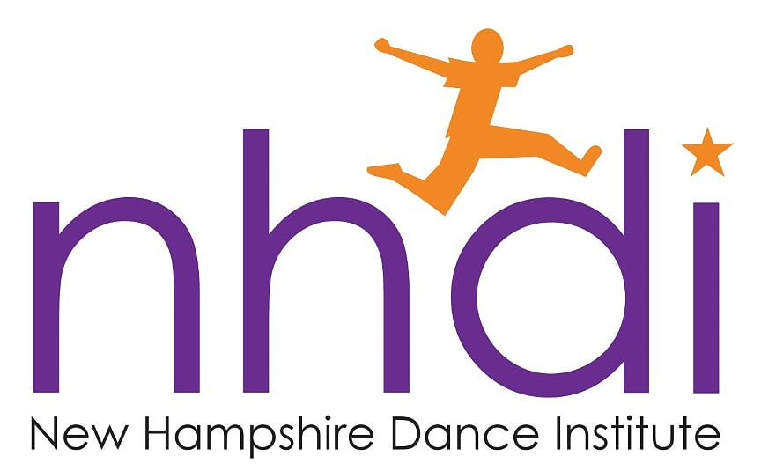

New Hampshire Dance Institute (NHDI) offers an exciting year-long program that requires discipline, exercise and hard work while promoting teamwork and self-esteem. Dancers
learn to jump on the beat, turn on a dime, and control their growing, changing bodies while mastering choreography in weekly classes during their school day under the direction of professionally trained dance teachers.
Will be holding a sample class on

__________________________
Please join us!

New Hampshire Dance Institute (NHDI) offers an exciting year-long program that requires discipline, exercise and hard work while promoting teamwork and self-esteem. Dancers learn to jump on the beat, turn on a dime, and control their growing, changing bodies while mastering choreography in weekly classes during their school day under the direction of professionally trained dance teachers.
Will be holding a sample class on

_____________________________
Please join us!

